The Above 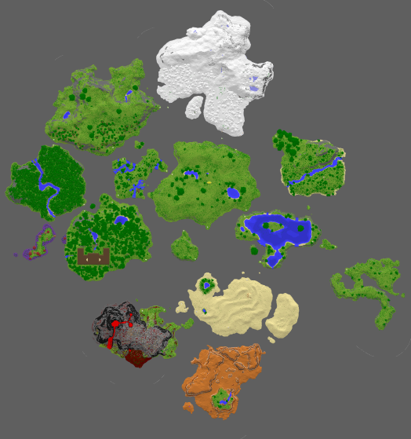

Map of The Above

The **Above** is a deadly dimension modded in Titancraft. The **Above** is filled with crazy landscapes, bosses, puzzles, and a horde of crazy strong hostile mobs. This guide was created by avivg2001, with Trollentia helping to fill out some of the information, and Arvital editing the document. This guide should be considered a work in progress, and as such has parts that need to be filled out and/or edited. If you are willing to contribute to the guide, or if you have any questions you may contact avivg2001 through Discord.

## Accessing

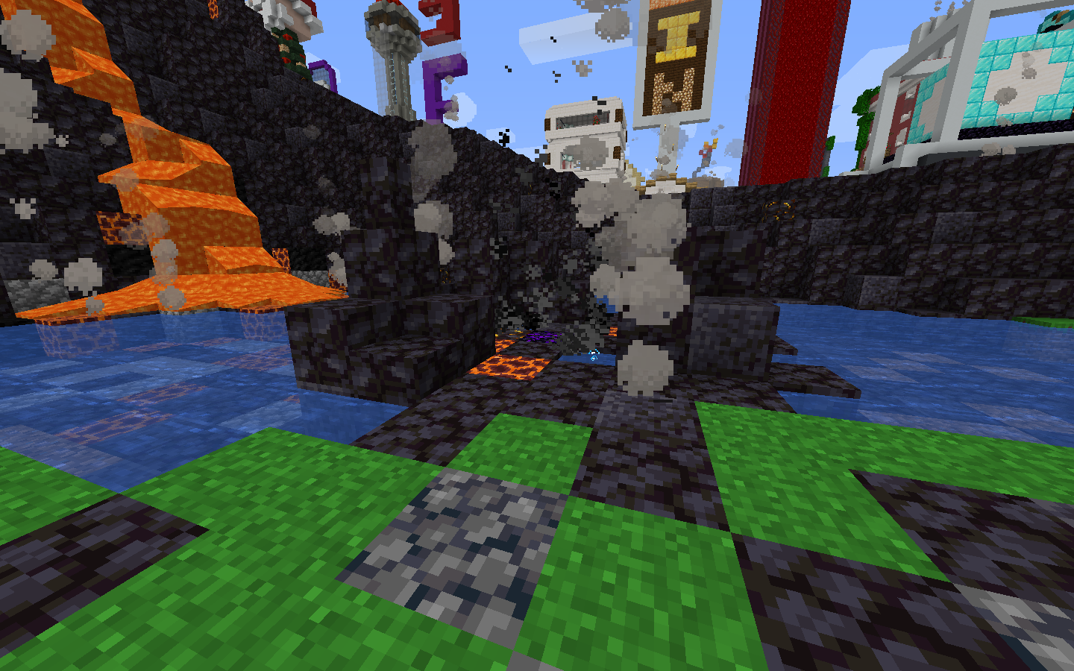

The geysir used to access The Above

To access the Above, the player needs to stand in the middle of the geysir, which is marked by crying obsidian. Once the player stands on the crying obsidian, they will be launched to the Above, and will land in a lake to prevent fall damage. The geysir generates a sound effect of explosion when launching, but will deal no damage to the player.

## Traits

The Above is formed by a bunch of floating islands separated by the “Void”. A player which falls off into the void will be teleported to the Overworld, high in the sky over the Shopping District. The player will safely land inside the lake near the geysir.

The Above is Adventure Mode only, so players can't break or place any item or block there, but will be able to interact with chests, leavers, buttons etc.

Most creatures found in the Above are hostile and deadly.

No matter how far you will fly, when going back to the Overworld you will get back to the geysir at spawn.   
The islands in the Above have teleport gates which allow a player on foot to move from island to island.

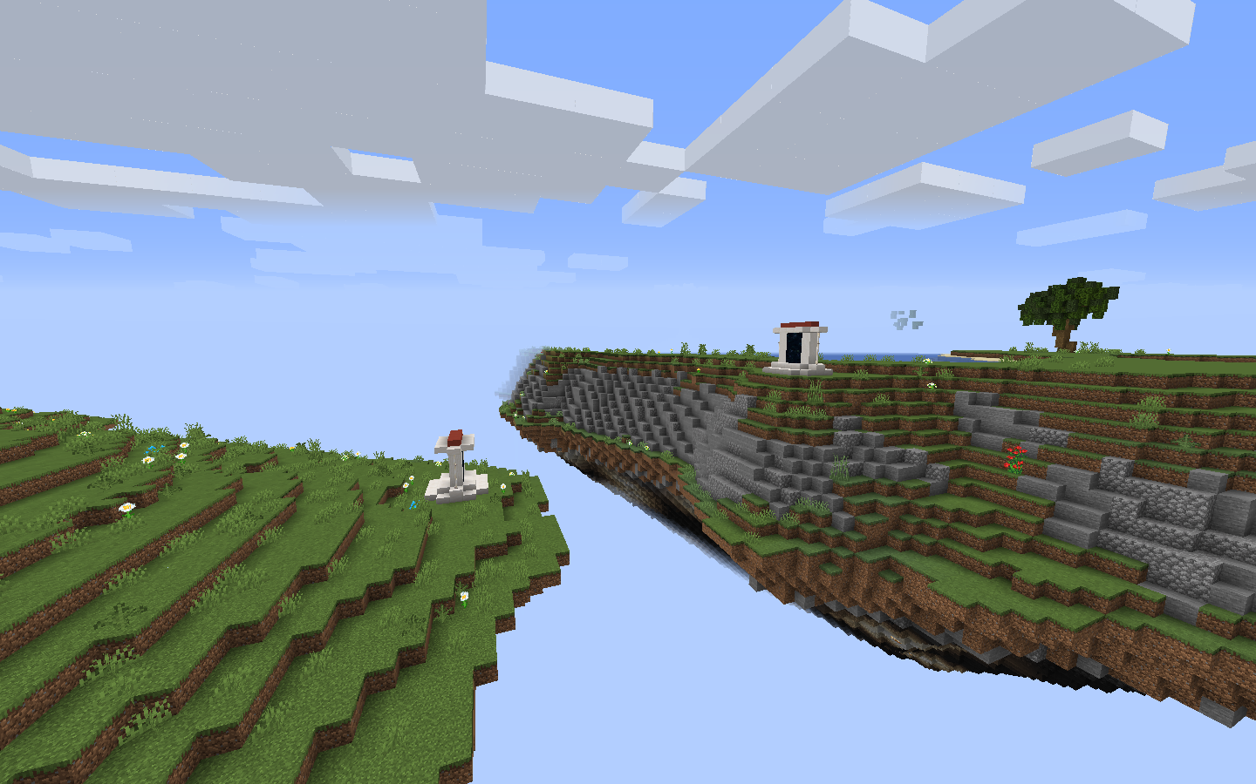

An image of the Above with gates that let you travel between islands.

## Environment

The Above features a unique terrain formed by biome-specific islands in the sky. Between the islands is a vast expanse of nothingness known as the Void.

## Biomes

The Above is divided into several biomes just like the Overworld, but each island represents a different biome

| **Biome Name** | **Description** | **Image** |
| --- | --- | --- |
| **The Swamp** | The Swamp is on the west side of the Above, and contains the witch hut, which is where Gremora spawns. |  |
| **The Savanna** | The Savanna is on the east side of the Above, and contains some parked cars, which is where Von Fiend spawns. |  |
| **The Lake** | The Lake is on the south side of the Above, and hidden under the Lake lies a pirate cave. |  |
| **The Snowy Biome** | The Snowy Biome is on the north side of the Above, and contains an icy cave system under its mountains which is where Kermode spawns. |  |
| **The Flower Forest Biome** | The Flower Forest biome is on the north east corner of the Above, and contains a lot of bee nests and a honey cave which is where the Bee Queen spawns. |  |
| **The Forest** | The Forest is on the north west side of the Above, and contains inside of it a spider cave full of cobwebs, the main entrance to Broodmother’s cave. |  |
| **The Desert** | The Desert is on the south side of the Above. The Desert contains one of the entrances to Broodmother’s cave, and a pyramid that is currently not open. |  |
| **The Volcano** | (need information) |  |
| **The Mesa** | The Mesa is souther to the Above. The mesa biome contains inside of it a U.F.O on the south part of the Mesa |  |
| **The Mixed Biome** | The Mixed Biome is in the far south east of the Above. The Mixed Biome contains inside of it the pig race. |  |

## Structures

There are a few notable structures in the Above.

| **Name** | **Description** | **Image** | **Location** |
| --- | --- | --- | --- |
| **The Mansion** | The Mansion is deep inside of the Dark Wood forest, and is guarded by a swarm of [vindicators](https://minecraft.gamepedia.com/Vindicator), [illusioners](https://minecraft.gamepedia.com/Illusioner), [evokers](https://minecraft.gamepedia.com/Evoker) and [spiders](https://minecraft.gamepedia.com/Spider). The Mansion also contains a puzzle that at top that awards a prize to up to eight players who solve it. This puzzle changes when it respawns. (need more information) |  |  |
| **The U.F.O** | The U.F.O is on the south side of the Mesa biome. When standing below the U.F.O it will suck the player up to it. on the U.F.O mooshroom can spawn, and inside of the U.F.O there is a chest that a titan shard could spawn inside |  |  |
| **The Mesa Mines** | The Mesa Mines are inside of the Mesa biome. in those Mines spawns some very fast spiders that deal a lot of damage and knockback, and some chests that contains loot |  |  |
| **The Pyramid** | The Temple is a medium sized pyramid with a booby trapped, randomised maze on the inside, there are many hazards and booby trapped chests inside.  There are two main types of traps, Spawner and Lava traps.  Lava traps are normally signified by the presence of red sand or red sandstone. Opening a chest in a red sandstone decorated room will cause lava to fountain from the ceiling or exchange with the floor. Caution is advised when opening chests such as these, although the traps are usually predictable and easy to avoid with ender pearls.  Spawner traps will be shown by a sarcophagus on which the chest is placed opening these will cause husks with strength and speed buffs holding gold swords to spawn. They can easily overwhelm a small party. So be prepared for a fight if you decide to open these chests.  While the visible chests are trapped, they do contain some decent loot. Loot has contained blaze powder, diamonds, emeralds, coupons, obsidian, blocks of iron, coal, charcoal, blackstone, gilded blackstone, and other usual above chest loot.  In conjunction to the openly visible chests, there are also hidden ones, behind lava falls, and hidden above and below the various lava pillars scattered around the maze. These contain better loot then the openly visible chests, so be sure to check every nook and cranny.  Also throughout the maze is one big puzzle. The maze has gold blocks with netherite swords in item frames on them. Either on pillars, or on walls. These item frames cannot be interacted with. As you explore the rooms you will find the heart of the maze, a giant pillar in the centre of the room with gold blocks and swords in the corners that you can interact with. You must match up the sword directions you find in the maze with the ones on the pillars in this room to unlock the treasure vault portal. Leading to the grand prize of the maze; 2 Titanshards per person! Netherite ingots and scraps are also part of the loot.  Some things to note about the temple is that fire resistance does not work, from Enchanted Golden Apples, totems, or potions. So do not try to bring fire resistance to outsmart the maze.  If you wish to take on the temple, you will want some decent weapons and a full set of armour. Ender pearls will make the maze easier to navigate, and while fire resistance will not work, fire protection enchantments will. Bring lots of food and maybe some instant health potions too as they not only heal you, but also damage the husks too as they are undead creatures. |  |  |
| The Shrine of Kovic | The Shrine of Kovic is on a small island in the far part of The Mixed Biome. The shrine is where Kovic spawns. (more information needed) |  |  |
| The Pigsty + the pig race | The Pigsty is inside of the Mixed biome on the north east part of it. 4 players are needed to start the race. Once everybody chooses a pig to race on, the race will begin (make sure you have an open hand before you start). The 4 players will race around the island collecting “points” (purple beacon beams. run into them to collect a point) if you fall off the island, you are disqualified. The first to 8 points finishes the game. (more information needed) |  |  |

## The Boat race

NOPE! nope nope nope nope nope nope nope! I am NOT going to be writing that! here i will give you the coordinates, you can figure out yourself what you gotta do I am NOT writing that, if you find this guide useful then would be nice if you write that yourself, here you go have fun:

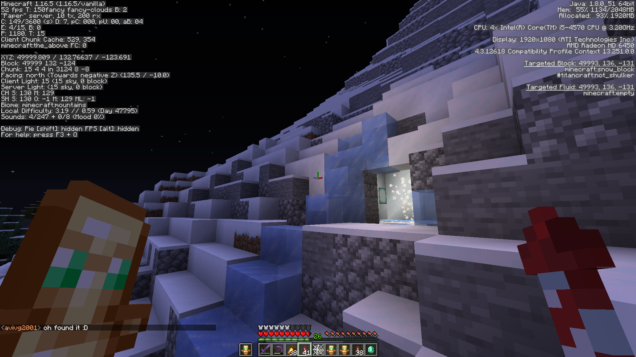

## Bosses + Mobs

The Above contains a multitude of boss monsters, who drop the coveted Titan Shards upon defeat.

| **Image** | **Name** | **Information** | **reward** |
| --- | --- | --- | --- |
|  | Bee Queen (boss) | The Bee Queen spawns in the Flower Forest biome. She is not very strong compared to other bosses, but she makes up for that by having a literal swarm of soldier bees that will attack any player or creature nearby. If a player manages to kill only the Queen and not the servants they will achieve the **Clean Coup** advancement.  Strategy: kill the queen bee, FAST. highly suggest entering to the hive full gear and with totems.  **Difficulty Level: Medium** | 1 Titanshard  1 stack of Wither Roses |
|  | Von Fiend  (boss) | Von Fiend spawns in the Savanna biome near the cars. He is a supernaturally buff Vindicator that has a huge number of hit points and hits hard enough to kill a player in two hits. Von Fiend is also skilled, as he only kills his enemies by chopping their head clean off. When a player is murdered by Von Fiend for the first time they will achieve the **Off with your head**! achievement. When von Chop the players head of he will hold that head in his hand, and when picking up a new head it will replace the one he was currently carrying. The head which Von holds upon death will drop on the ground and the player could pick it up.  Strategy:   * attack from a short tree and whack a Von with your sword until he dies * make Von chase you inside the river, it will slow him down and make him an easier target.   (arrows do no damage)  **Difficulty Level: Hard** | 4 Titanshards  Head Hunter Axe |
|  | Gremora  (boss) | Gremora spawns inside the witch hut in the Swamp biome. While Gremora is active, normal witch mobs will spawn in and around her hut and are hostile to the player. When engaged she will do the usual witchy thing of tossing Potions of Poison--but what makes her unique is her ability to teleport after taking a certain amount of damage, leaving a Lingering Potion of Slowness in her wake. Gremora’s ability to teleport to a random spot inside or outside the hut gives her time to drink Potions of Healing to restore her massive HP pool. Since the player is slowed down, it becomes difficult to catch up to her before she fully heals.  Strategy:   * it is a very hard battle, first time fighting should be with a group of players while each player on different level of the witch hut * Strength II pots and Spectral arrows to know the location of Gremora when she teleports. * Healing, Regeneration, food, full armor, totems suggested because Gremora and her witch minions deal a lot of damage. * ender pearls to get to her faster when slowed down by her slowness pots.   A player that kills Gremora alone will achieve the **It Cost Everything** achievement**.**  **Difficulty Level: Hard** | 2 Titanshards  Occasionally 1 random Above potion with a unique effect  ~64 of a regular witch drop such as glowstone dust or sticks |
| / | Volt  (boss) | Volt spawns in his own little island just south of the central spawn island. He is an iron golem infused with the power of ELECTRICITY allowing him to zap players, spawn charged creepers, and move at lightning speeds. Due to the nature of the fight, it is easy to get killed immediately after a totem pop. Volt has several different custom attacks, including hurling the player up into the air, leaping into the air and stomping on the player, summoning lightning bolts, and charging creepers.  Getting hit by one of his lightning bolts grants the achievement **thunder struck**.  Luckily, Volt is still an iron golem and as such has AI that the player can use to their advantage: he will always prioritize attacking hostile mobs, including phantoms. This can help give the player time to recover from his fast, unrelenting damage output.  **Recommended gear:**   * Chestplate!!! * blast protection is another idea for the creepers, need to test further. * Ender pearls are a must to mitigate fall damage when he tosses you up. * Bow and spectral arrows, he's vulnerable to arrow damage and a fully drawn power 5 spectral shot should 1-shot a charged creeper. * Sharp 5 sword/axe. * Potions of regen, strength, and speed. * Many many totems.   **Strategy:**   * volt will attack hostile mobs first like any normal golem, so night time could come in handy. * make sure to do prepperations before the fight, you won’t have time to do that when landing on his island. * creepers do lots of damage, be sure not to get hit by their explosion while fighting. Even if the explosions don't 1-shot you they do a lot of durability damage and no one likes that. * Volt will begin to show signs of damage like a regular golem to show his health. * One way is to melee him, or try to get him by arrows and elytras but that would cost a lot of rockets. * Pearls are necessary when volt lunches the player to the air to avoid massive fall damage, and to get away from volt to eat to regen or consume more potions. * Friends to help take him down quicker is always a good idea, Especially if it's the first time you fight volt. * for the first time suggested to use backup gear because the creepers could blow up everything after the player death.   **Difficulty Level: Very hard** | 4 Titanshards 1 SpEciAL Poppy |
|  | Kermode  (boss) | Kermode spawns in the Snowy biome inside of a cave. I don’t have much to say here, she’s a bear. She mauls you. if a player defeats Kermode without a weapon that player gets the **With my Bear hands!** achievement.  Strategy: there is not much strategy for this boss sinces he is pretty easy. Kermode is pretty fast and can do some damage when it hits the player. suggested shooting arrows from the entrance or full gear and strength II potion to make things faster.  **Difficulty Level: Easy** | 1 Titanshard ~64 blue ice |
|  | Broodmother  (boss) | The Broodmother is a spider that makes her lair inside of a web-filled cave in the Forest biome. There are several entrances to her cave, allowing players a choice in how to approach the fight. The cave spawns cave spiders constantly, which amps up the difficulty of the fight. The Broodmother has seen fit to festoon her arena with cobwebs, which make it difficult to maneuver and fight her.  **Difficulty Level: Medium** | 3 Titanshards ~64 cobwebs |
|  | Kovac  (npc) | Kovac is a villager that spawns inside of the shrine at the far end of The Plains. He spawns as a zombie village full diamond gear, and when he is being converted back to village with a golden apple and a weakness potion the player will receive the **“An Apple a Day”** advancement and be able to turn armor into chainmail armor. (more information needed). when cured Kovac will reward you with a titanshard. | none |
|  | Beau  (npc) | Beau is a wanderer merchant that spawns in different locations every in game day during daytime. players can buy from Beau mini blocks (1 shard + specific block = 8 mini blocks), and when they do they get the “**Its a small world”** advancement, the **“Second pickings”** if a player buys something that wasn’t sold last time, and if they buy everything they get the **“Everything must go”** advancement. | none |

## 

## Loot

The Above contains a wealth of loot that differs greatly from the standard Vanilla Survival game of Minecraft.

### Bosses and Chests

| **Image** | **Name** | **Information** |
| --- | --- | --- |
|  | Titan Shard | Titan Shards are obtained by defeating mob bosses or solving the Mansion puzzle. These Titan shards later can be traded in to get unique rewards, including weapons, armor, and equipment with impossible to craft enchantments! |
|  | Head Hunter Axe | The Head Hunter Axe is obtained by defeating Von Fiend. This axe has 1 durability and is capable of one-shotting any normal mob in the game. Hitting a mob with it will destroy the axe, and reward the player with the head of the mob. |
|  | Disappearing Potion | Gives the player 15 mins of invisibility. |
|  | Draught of deadliness | Haste II (3:00)  When Applied +20% Attack speed. |
|  | Blackness Brew | blindness (5:00) |
|  | Distilled Daylight | Night vision (30:00) |
|  | salamander serum | Fire Resistance (30:00) |
|  | BOOM stick | Knockback X |
|  | Coupons | There are a variety of things coupons can do that players could not be able to do in vanilla survival. Each kind of coupon allows the player to do a diffrent thing, and when used they disappear. Most of the coupon can be redeemed in the Kiosk under the volcano pathway at spawn.  Name coupon: This coupon allows the player to rename an item using custom formatting and colors.  Enchantment coupon: This coupon allows the player to make an item looks enchanted  Banner coupon: This coupon allows the player to make a banner with more than just 6 patterns.  Mini-Block coupon: This coupon allows the player to get one custom head from the internet.  Lore coupon: This coupon allows the player to apply custom lore text to an item.  Armor stand coupon: allows the player to modify an armor stand as he wish (like Zombie-Cleo armorstand work but without the book and alot of coupons are needed)  Block coupon: allows the player to obtain a block that they wouldn’t be able to get in vanilla survival (must be accepted through mods first)  Book/sign coupon: allows the player to apply custom text on a sign or inside a book with different formats and colors.  Item frame coupon: allows the player to make Item Frames invisible…? I don't know what else  Mob modification coupon: allows the player to change a mob AI as they wish (for example removing their AI, making them passive ect…)  spawner coupons: allows the player…. pls help me I don't know what a spawner coupon does D:  Armorstand, block, book/sign, Item frame, mob modification, spawner coupons cannot be redeemed automatically through the Kiosk and will have to be redeemed through Grifter (or other mod if it will change)  visit the Kiosk for further information about each coupon. |
|  | Power Potion | 15 minutes of conduit |
|  | Liberation Libation | 5 minutes HOTV |
|  | Cannon Cola | Get transported to the above |
|  | Dolphin’s Dose | 5 minutes Dolphin’s Grace |
|  | Feather Philter | 15 minutes of feather falling |
|  | Luck | 1 minute of luck |
|  |  |  |
|  |  |  |
|  |  |  |
|  |  |  |
|  |  |  |
|  |  |  |
|  |  |  |
|  |  |  |
|  |  |  |
|  |  |  |
|  |  |  |
|  |  |  |
|  |  |  |
|  |  |  |

## Titan Shard Loot

Titan Shards are currency that are used to acquire random special loot from the Titan Shard island. It is recommended to have someone show you the process the first time you try to do this. The Titan Shard island is easily accessed through a portal in the Nether hub.

### How to Trade

By placing three Titan Shards upon the netherite block pedestal, the player will receive a random unique item from the list. By sacrificing a fourth Titan Shard, the player can limit the random item to a specific category: (tools, weapons, armor, potion, resource, coupon). Once the three Titan Shards are placed on the pedestal, they will be consumed and a hole will appear in the floor in the middle of the island. The hole will teleport the player to a room with a chest that will contain the loot.

### eEnchantments

Due to the unique nature of the Titan Shard loot, some of the enchants require explaining. This list is always in-progress and incomplete. If you know more, contact avivg2001 on Discord

| **Name** | **effect** | **comes on** |
| --- | --- | --- |
| Philia: (block) | Turns one kind of block to a specific block that is written in the (block) space  For example, when used on leaves it causes saplings of the named Philia type to drop even if one is not using shears or silk touch (ie. breaking spruce leaves yields acacia saplings with Philia: Acacia) | Axe  Shears  Hoe |
| Green thumb | It make things “green” | Tools |
| Void | The player gets no loot from mobs | Tools/Weapons |
| Pulverize | Turns coarse dirt into gravel, and gravel into sand. Nether wart blocks to nether warts | Shears and Shovels |
| Extract | Can do the following things wet sponges -> water buckets andesite -> diorite granite -> nether quartz diorite -> nether quartz | Tools |
| Bleach | Removes the dye color from blocks.  Removes the dye when you break the block with the tool- Does not return the dye | Tools |
| Squid Jig | Gives the fishing rod a higher chance to pull up an ink sack.  Sadly it does not make a squid dance :( | Fishing Rod |
| Catch and Release | Have a chance to catch buckets with fish inside. The buckets can obtain cods, salmons, puffer-fishes, and all kinds of tropical fish. | Fishing rods |
| Forge | Changes blocks as if they had been through a smelter.  Ore > Ingots Sand > Glass Sandstone > Smooth sandstone Quartz block > Smooth Quartz block Netherrack > Nether bricks (the loose bricks not the block) Nether brick block > Cracked nether brick Polished blackstone brick block > Cracked polished blackstone brick block Doesn’t work on stone bricks for some reason. | Tools, fishing rods |
| Chisel | Changes items to a different variant (ironically not their chiseled one in most cases.)  Sandstone > Cut sandstone Quartz block > Quartz brick block Nether brick block > Chiseled nether brick (Does not seem to work on stone bricks or polished/any kind of blackstone.) | tools |
| Angler | Only catches Fish (no Junk or Treasure). | Fishing rod |
| Rush | Permanently gives you the speed beacon effect | Pants |
| Picky | Eliminates the chance for Junk or Treasure, and increases the chances for Tropical or Pufferfish (decreasing the chances of Cod)[1] | Fishing Rod |

Advancements[[edit](https://minecraft.gamepedia.com/The_Nether?action=edit&section=17)].

| **Icon** | [**Advancement**](https://minecraft.gamepedia.com/Advancement) | **In-game description** | **description** |
| --- | --- | --- | --- |
| Advancement-plain-raw.png | **Look up, waaaay up!** |  | get to the above for the first time. good luck up there, you will need it, |
| Advancement-plain-raw.png | **Down to Earth** |  | Jump off the above, off you go! |
| Advancement-plain-raw.png | **A swine-r is You** | Complete a pig race | weee! |
| Advancement-plain-raw.png | **Ice science enrichment center** | complete all five iceboats courses | Wwweeeeeeeeeeeeeeeeee!!! |
| Advancement-fancy-raw.png | **This Was a Triumph** | get on a full leaderboard | WWWWEEEEEEEEEEEEEEEEEEEEEEEEEEEE!!!!!!!!!  HAHAHAHAHA!!!! |
| Advancement-plain-raw.png | **Save me tango!** |  | You did it! you have slayed your first above mob! that's a start. |
| Advancement-fancy-raw.png | **Cleaning house** |  | well thats impressive, you just commited a genocide! |
| Advancement-plain-raw.png | **Defeat each of the Above’s boss mobs** |  | Geez. If you get this achievement you are a legend! maybe let some others try getting this achievement too. |
| Advancement-fancy-raw.png | **Thunder- struck** |  | Ouch! this lighting really hurts! |
| Advancement-fancy-raw.png | **Off with your head!** |  | "Greeting sirs, This is me von the merchant and I have been wandering in these lands chopping heads of a variety of players. Would you like me to chop your head off? its free!" |
| Advancement-plain-raw.png | **An Apple a Day** |  | An Apple a Day will keep the doctor away, but a golden apple will keep kovac curse away. |
| Advancement-fancy-raw.png | **Clean coup** |  | It is a hive mind, once the head is gone, everything is falling apart. all you gotta focus is the head. |
| Advancement-fancy-raw.png | **It Cost Everything** |  | now THAT'S impressive! must have been an epic battle… can’t believe you didn’t waited for me, I would have brought along some popcorn! |
| Advancement-plain-raw.png | **With my Bear hands!** | punch kermode to death :( | hehe, Kermode goes Brrrrrr…... |
| Advancement-fancy-raw.png | **Where’s the Flame- thrower?!** | Kill Broodmother with a Flame bow |  |
| Advancement-plain-raw.png | **It’s a Small World** |  | and so the head collection begins |

1. Based on 100 test catches with 0 Luck of the Sea. Expected 5 Treasure and 10 Junk, received 0 Treasure and 0 Junk. Ignoring those categories, would've expected 60 Cod, 25 Salmon, 2 Tropical, and 13 Puffer. Caught 32 Cod, 30 Salmon, 12 Tropical, 26 Puffer.